LINUX FILE SYSTEM
A file system is a way of organizing files on your partition. Besides file-based storage, file systems usually include directories and access control, and contain meta information about files like access times, modification times and file ownership.
filesystems - Linux filesystem types: ext, ext2, ext3, ext4, hpfs, iso9660, JFS, minix, msdos, ncpfs nfs, ntfs, proc, Reiserfs, smb, sysv, umsdos, vfat, XFS, xiafs
ext is an elaborate extension of the minix filesystem. It has been completely superseded by the second version of the extended filesystem (ext2) and has been removed from the kernel (in 2.1.21).
ext2 is the high performance disk filesystem used by Linux for fixed disks as well as removable media. The second extended filesystem was designed as an extension of the extended filesystem (ext).
ext3 is a journaling version of the ext2 filesystem. It is easy to switch back and forth between ext2 and ext3.
ext4 is a set of upgrades to ext3 including substantial performance and reliability enhancements, plus large increases in volume, file, and directory size limits.
hpfs is the High Performance Filesystem, used in OS/2. This filesystem is read-only under Linux due to the lack of available documentation.
JFS is a journaling filesystem, developed by IBM, that was integrated into Linux in kernel 2.4.24.
minix is the filesystem used in the Minix operating system, the first to run under Linux. It has a number of shortcomings, including a 64 MB partition size limit, short filenames, and a single timestamp. It remains useful for floppies and RAM disks.
ncpfs is a network filesystem that supports the NCP protocol, used by Novell NetWare. To use ncpfs, you need special programs, which can be found at ⟨ftp://linux01.gwdg.de/pub/ncpfs⟩.
nfs is the network filesystem used to access disks located on remote computers.
ntfs replaces Microsoft Window's FAT filesystems (VFAT, FAT32). It has reliability, performance, and space-utilization enhancements plus features like ACLs, journaling, encryption, and so on.
XFS is a journaling filesystem, developed by SGI, that was integrated into Linux in kernel 2.4.20.
Btrfs: made by Oracle. It is not stable as Ext in some distros, but you can say that it is a replacement for it if you have to. It has a good performance.

Mounting
mount -t file_system_type device_to_mount directory_to_mount_to
unmount device_to_mount
FILE SYSTEM

SHAREABLE FILE SYSTEM NON-SHAREABLE FILE SYSTEM
..also,

STATIC FILES VARIABLE FILES
( binaries, libraries , doc files)
: cannot change w/o system : all other files other than static files : administrators intervention :

LINUX BASICS (extras)

Directory:
Directory is itself a file that holds addresses of different files.
Root : /
Root User : different from root(/)

bin : where all the programs live on the machine.
Boot : necessary files required at the time of bootup.
Dev : all devices, mouse,keyboard,cdrom, everything are devices and is stored as a file here
etc : holds all the config files for the system.
Home : is example of harddrive mounted on the system.
Lib and lib64 : where all libraries live. ( || to DLLs in windows. )
media : plugin usb/........ comes under media.
Opt : optional proprietary softwares. eg. Teamviewer ,google
tmp : temporary
everything except home folder requires admin privileges
var : all important logs, local files, caches , basically the variable data.
Sbin : system-binaries, where all the system commands lives.
Usr : universal system resources.
Etc : contains shadow files and config files.
Lib : contains shared libraries used by sytem.
Mnt : usb drivers/cdrom etc.
Proc : procedure directory contains VFS & kernel information
................................................................................................................................
$ -> normal user login
# -> root user login
To become root user,
1. sudo -i
2. “enter password”
To check, perform “whoami” o/p -> root
FOR ROOT USER,
uid = 0
gid = 0
groups = 0

Few File types :
Mouse – character special file
Disk – Block special file
Printer – Character special file

inode:
0 -12 => 13 blocks
0.....9 – point to blocks
10 – Single indirect
11 – Double indirect
12 – Triple indirect
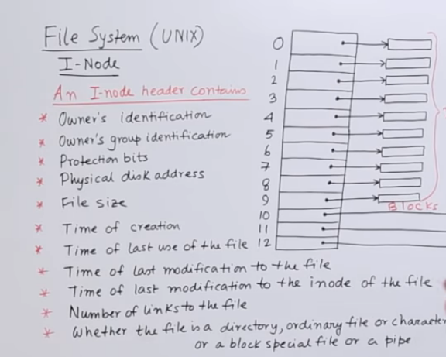
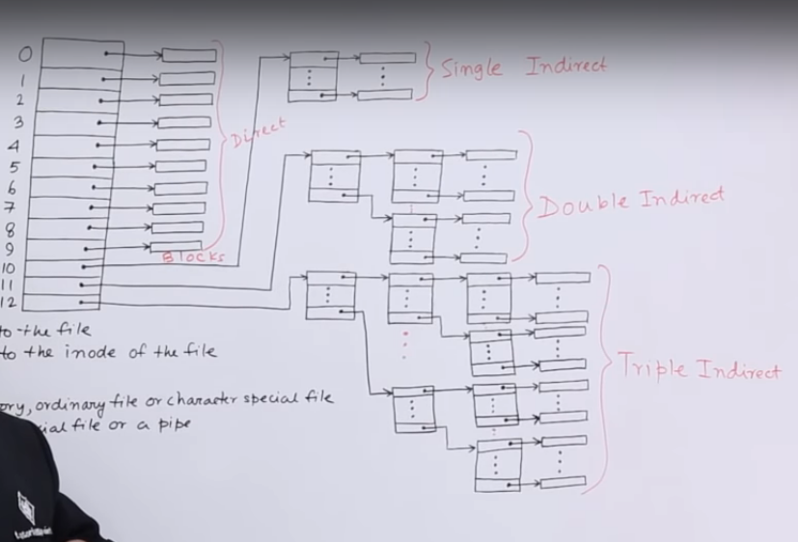

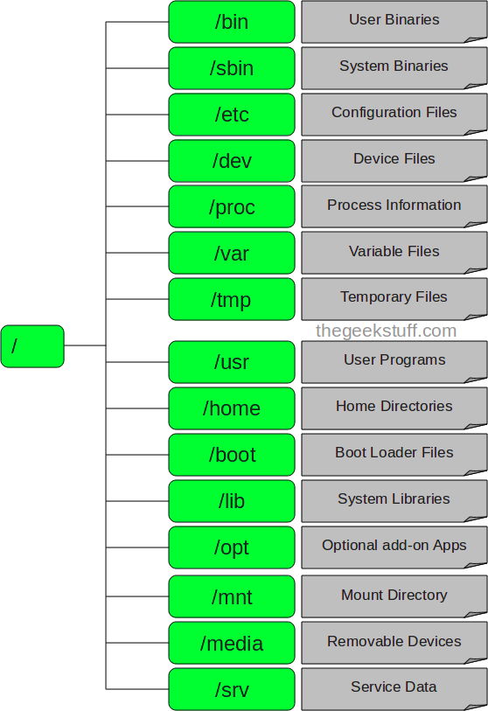

1. / – Root
- Every single file and directory starts from the root directory, i.e. the base of the file system.
- Only the root user has write privilege under this directory.
- /root is the root user’s home directory, which is not the same as /.

2. /bin – User Binaries
- Contains binary executables.
- Common linux commands you need to use in single-user modes are located under this directory.
- Commands used by all the users of the system are located here.
- For example: ps, ls, ping, grep, cp.
- Eg. ls,cat

3. /sbin – System Binaries
- Just like /bin, /sbin also contains binary executables.
- But, the linux commands located under this directory are used typically by system administrators, for system maintenance purposes.
- For example: iptables, reboot, fdisk, ifconfig, swapon

4. /etc – Configuration Files
- Contains configuration files required by all programs.
- This also contains startup and shutdown shell scripts used to start/stop individual programs.
- For example: /etc/resolv.conf, /etc/logrotate.conf

5. /dev – Device Files
- Contains device files.
- These include terminal devices, usb, or any device attached to the system.
- For example: /dev/tty1, /dev/usbmon0

6. /proc – Process Information
- Contains information about system process.
- This is a pseudo file system containing information about the running process. For example: /proc/{pid} directory contains information about the process with that particular pid.
- This is a virtual filesystem with text information about system resources. For example: /proc/uptime

7. /var – Variable Files
- var stands for variable files.
- Content of the files that are expected to grow can be found under this directory.
- This includes — system log files (/var/log); packages and database files (/var/lib); emails (/var/mail); print queues (/var/spool); lock files (/var/lock); temp files needed across reboots (/var/tmp);

8. /tmp – Temporary Files
- Directory that contains temporary files created by system and users.
- Files under this directory are deleted when the system is rebooted.

9. /usr – User Programs
- Contains binaries, libraries, documentation, and source-code for second level programs.
- /usr/bin contains binary files for user programs. If you can’t find a user binary under /bin, look under /usr/bin. For example: at, awk, cc, less, scp
- /usr/sbin contains binary files for system administrators. If you can’t find a system binary under /sbin, look under /usr/sbin. For example: atd, cron, sshd, useradd, userdel
- /usr/lib contains libraries for /usr/bin and /usr/sbin
- /usr/local contains users programs that you install from source. For example, when you install apache from source, it goes under /usr/local/apache2

10. /home – Home Directories
- Home directories for all users to store their personal files.
- For example: /home/john, /home/nikita

11. /boot – Boot Loader Files
- Contains boot loader related files.
- Kernel initrd, vmlinux, grub files are located under /boot
- For example: initrd.img-2.6.32-24-generic, vmlinuz-2.6.32-24-generic

12. /lib – System Libraries
- Contains library files that supports the binaries located under /bin and /sbin
- Library filenames are either ld* or lib*.so.*
- For example: ld-2.11.1.so, libncurses.so.5.7

13. /opt – Optional add-on Applications
- opt stands for optional.
- Contains add-on applications from individual vendors.
- add-on applications should be installed under either /opt/ or /opt/ sub-directory.

14. /mnt – Mount Directory
- Temporary mount directory where sysadmins can mount filesystems.

15. /media – Removable Media Devices
- Temporary mount directory for removable devices.
- For examples, /media/cdrom for CD-ROM; /media/floppy for floppy drives; /media/cdrecorder for CD writer

16. /srv – Service Data
- srv stands for service.
- Contains server specific services related data.
- For example, /srv/cvs contains CVS related data.
Types of files in linux :

- : regular file

d : directory

c : character device file

b : block device file

s : local socket file

p : named pipe

l : symbolic link

man page says :
NORMAL 0 Normal (nonfilename) text
FILE 0 Regular file
DIR 32 Directory
LINK 36 Symbolic link
ORPHAN undefined Orphaned symbolic link
MISSING undefined Missing file
FIFO 31 Named pipe (FIFO)
SOCK 33 Socket
BLK 44;37 Block device
CHR 44;37 Character device
EXEC 35 Executable file

BASIC COMMANDS :

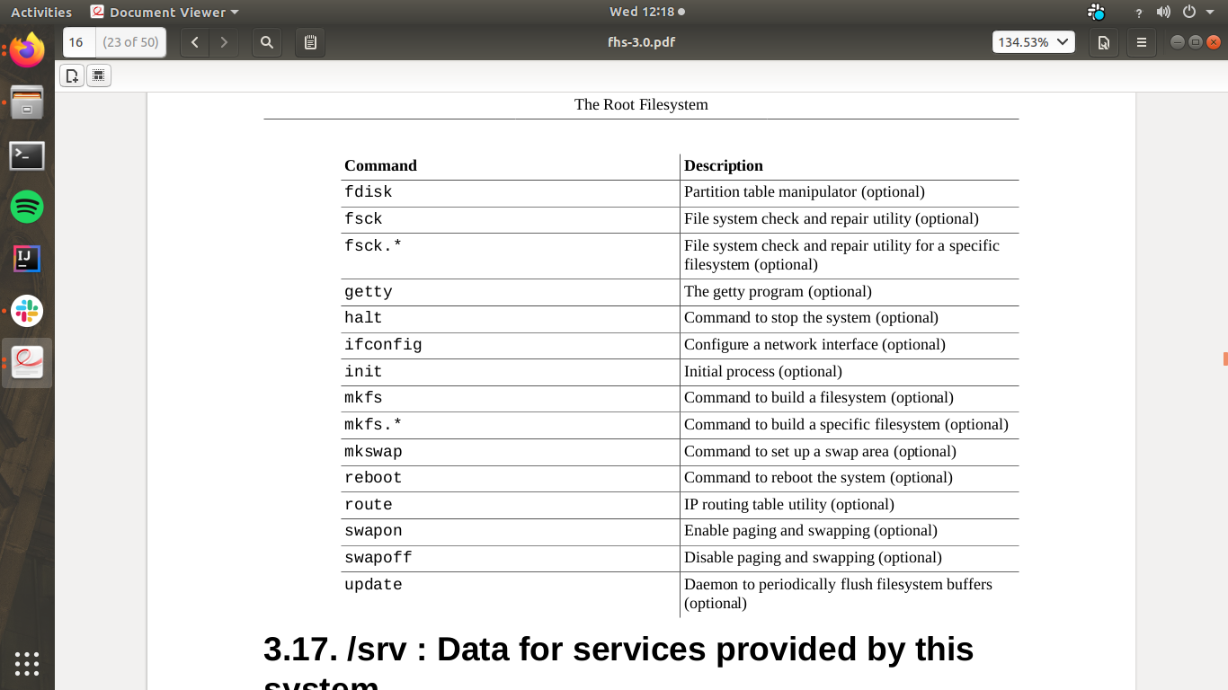

Ques: if everything is a file then when you use the ls command on the ~/Desktop why does it not show the trash . is it a folder, must be a file but then why not show it ?

Ans: There is no .desktop file for Trash in your ~/Desktop/ directory. The trash icon is a feature provided by GNOME shell and/or Nautilus, it's probably hard-coded somewhere.
………………………………………………………………………………………………………
You can enable/disable this feature using gsettings/dconf. Run the following to hide the trash icon from your desktop
gsettings set org.gnome.nautilus.desktop trash-icon-visible false

Trash’s location is ~/.local/share/Trash

gsettings set org.gnome.nautilus.desktop home-icon-visible true
gsettings set org.gnome.nautilus.desktop computer-icon-visible true
gsettings set org.gnome.nautilus.desktop trash-icon-visible true
gsettings set org.gnome.nautilus.desktop network-icon-visible true

TUNE A FILE SYSTEM
use tune2fs to list and set file system settings.

Note : Basics:

$# Stores the number of command-line arguments that
were passed to the shell program.
$? Stores the exit value of the last command that was
executed.
$0 Stores the first word of the entered command (the
name of the shell program).
$* Stores all the arguments that were entered on the
command line ($1 $2 ...).
"$@" Stores all the arguments that were entered
on the command line, individually quoted ("$1" "$2" ...).

Q. How to only list user names on Linux
To list only usernames type the following awk command:
$ awk -F':' '{ print $1}' /etc/passwd

What is awk ?
Awk is a scripting language used for manipulating data and generating reports.The awk command programming language requires no compiling, and allows the user to use variables, numeric functions, string functions, and logical operators.
Awk is a utility that enables a programmer to write tiny but effective programs in the form of statements that define text patterns that are to be searched for in each line of a document and the action that is to be taken when a match is found within a line. Awk is mostly used for pattern scanning and processing. It searches one or more files to see if they contain lines that matches with the specified patterns and then performs the associated actions.
Awk is abbreviated from the names of the developers – Aho, Weinberger, and Kernighan.
What do the different colours in Ubuntu's ls command mean?
Ans :
- Blue: Directory
- Green: Executable or recognized data file
- Sky Blue: Symbolic link file
- Yellow with black background: Device
- Pink: Graphic image file
- Red: Archive file
- Red with black background: Broken link

STREAMS
1. stdin
2. stdout
3. stderr

Few EXTRA FUNCTIONALITIES.

How to change root password in Ubuntu
The procedure to change the root user password on Ubuntu Linux:
- Type the following command to become root user and issue passwd:
sudo -i
passwd
- OR set a password for root user in a single go:
sudo passwd root
- Test it your root password by typing the following command:
su -

How to disable your root account on Ubuntu
One can disable the root account by typing the following command:
$ sudo passwd -dl root
OR
$ sudo passwd --delete --lock root
Sample session from the above commands:
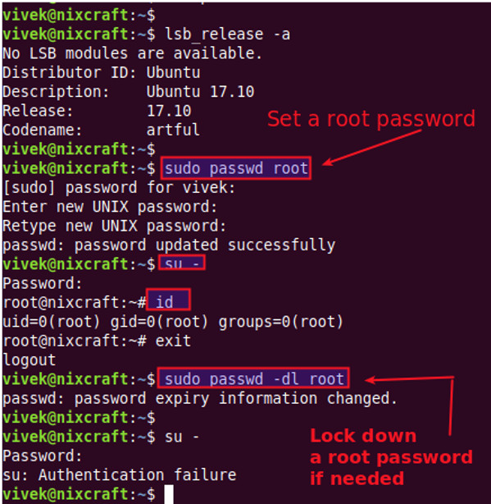

Understanding passwd command option
- -d OR --delete : Delete a user’s password (make it empty for root user). This is a quick way to disable a password for an account. It will set the named account passwordless.
- -l OR --lock: Lock the password of the named account such as root. This option disables a password by changing it to a value which matches no possible encrypted value (it adds a ‘!’ at the beginning of the password)
- root : Lock and disble root account i.e. re-disabling your root account

Q. Why does “ps aux | grep x” give better results than “pgrep x”?

ps aux includes the full command line (path and parameters), while pgrep only looks at the first 15 characters of the executable's names
ps aux returns the full command line of each process, while pgrep only looks at the names of the executables.
That means that grepping ps aux output will match anything that occurs in the path or the parameters of a process' binary: e.g. `
- ps aux | grep php5 will match /usr/share/php5/i-am-a-perl-script.pl
- but pgrep php5 won't
Take an example from my system -- only we'll use python instead of php5:
- ps aux | grep python gives us:
< OUTPUT >
izx 2348 0.0 0.7 514928 15644 ? Sl Jun24 0:00 /usr/bin/python /usr/lib/unity-lens-video/unity-lens-video
izx 2444 0.0 0.9 547392 18864 ? Sl Jun24 0:01 /usr/bin/python /usr/lib/unity-scope-video-remote/unity-scope-video-remote
root 2805 0.0 0.5 95436 12204 ? S Jun24 0:00 /usr/bin/python /usr/lib/system-service/system-service-d
izx 6272 0.0 2.9 664400 60320 ? SNl Jun24 1:16 /usr/bin/python /usr/bin/update-manager --no-focus-on-map
root 11729 0.0 0.9 180508 19516 ? S Jun25 0:00 python /usr/lib/software-properties/software-properties-dbus

- But pgrep python returns only 11729, which you'll see from the above list is:
root 11729 0.0 0.9 180508 19516 ? S Jun25 0:00 python /usr/lib/software-properties/software-properties-dbus
(understand the difference b/w the two)

